Phase 5

Total classes : 10

Day 5 : 9 Feb 2024

Amazon Web Service

S3, EC2 instance and EBS etc.

AWS S3 Service.

Simple Storage Service : it is type service provided by Amazon which help to share the any type of data with hight secure environment.

text file, pdf file, project, jar, war file etc

we can set the security to those data to access.

S3 Bucket : it is like a container which help to upload the data of any types.

Spring boot application and that application we run using eclipse IDE.

We need to create jar or war file of spring boot projects and that jar file or war file we need to share the other team to run the application.

We can create spring boot project with jar file with internal server ie tomcat and when we run that jar file it internally start internal tomcat to access that application.

We can create war file and exclude internal tomcat and we create war file and deploy that war file in external server like tomat, web logic, jboss etc.

Generally to create jar or war file we use mvn command.

Creating maven project using command prompt

mvn archetype:generate

after downloaded few dependencies

then hit enter key

then again hit enter key

groupId : myprojects

version : enter key

package name : com

then Y then it generate simple maven project

mvn validate

mvn complile : it create target folder which contains .class files

mvn clean : clean the project ie remove target folder which contains

.class files

mvn install

mvn package : it is use to create jar or war file.

mvn test : it is use to run the test case.

Spring boot project with web starter and thymeleaf as View

Create simple login page with check username and password manually.

Using mvn package command we will create jar file.

We run jar file using Java command and upload this jar in S3 bucket and deploy in EC2 instance.

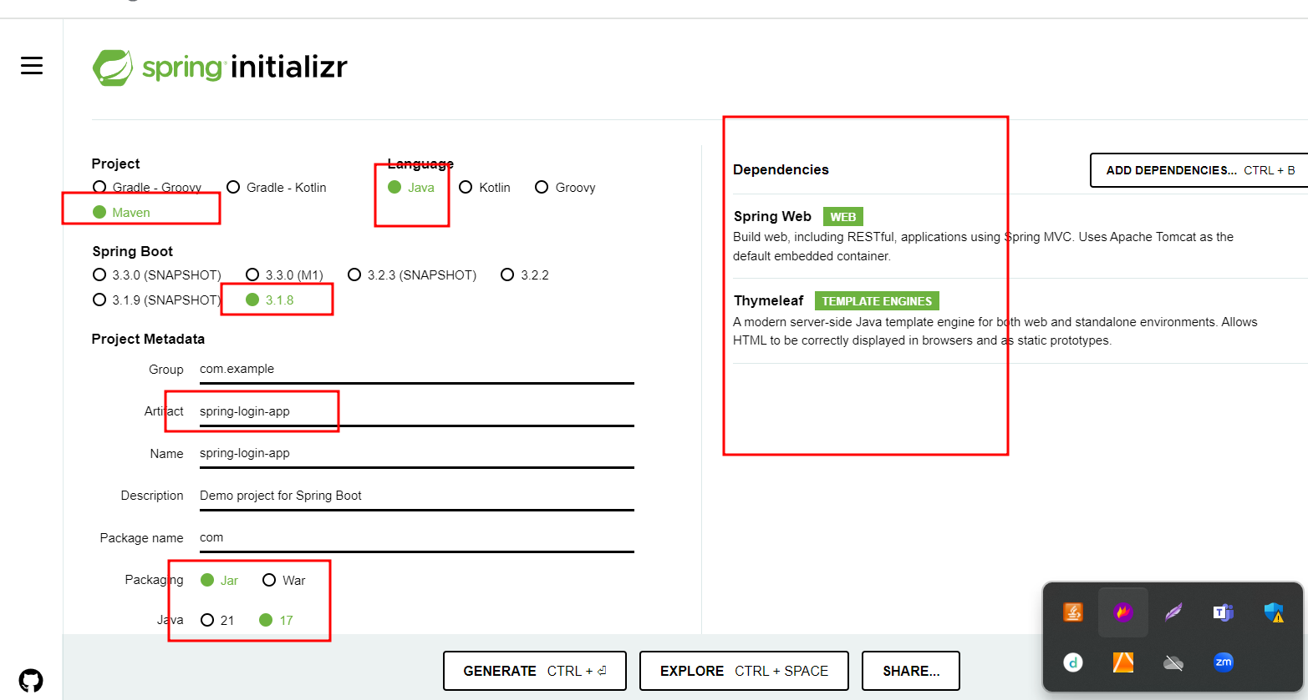

Running the spring boot application using jar file

Open the command prompt inside spring boot project. (pom.xml file location)

mvn clean

mvn compile

mvn package

cd target

java -jar filename.jar

Generally jar file present inside target folder which generated after mvn package.

java -jar filename.jar

AWS EC2 instance

Elastic Compute Cloud

AWS provided EC2 module which hep to create virtual server machine.

While creating EC2 instance we can configure what type of machine ie OS, RAM, memory and number of machine with same configure we create.

This machine provide public as well as private IP Address to access that machine.

Then EC2 instance is ready we need to connect that machine using command prompt or browser base.

Then installed required software like java, database, git, docker etc.

Then then run the application. Once you run that application can be java spring boot or angular in EC2 instance you can access that application using live or public Ip address.

Java -jar myfile.jar in local machine we can access using <http://localhost:9090>

If we run this jar file in EC2 instance then we can access this application using

<http://ipaddress:9090>

<http://www.akash.com>